17. Write a C program to arrange a series of numbers using Merge Sort

**Aim:** To write a C program to sort a series of numbers using **Merge Sort** algorithm. The program should:

* Take a list (array) of numbers as input.
* Sort the numbers in ascending order using merge sort (divide & conquer).
* Display the sorted array.

**Algorithm:** MergeSort(A, left, right)

Input: Array A[0..n-1], left = 0, right = n-1

1. If left < right then

a. mid ← (left + right) / 2

b. Call MergeSort(A, left, mid) // sort first half

c. Call MergeSort(A, mid + 1, right) // sort second half

d. Call Merge(A, left, mid, right) // merge the two sorted halves

2. End if

Procedure Merge(A, left, mid, right)

1. Let n1 = mid − left + 1 // size of first half

2. Let n2 = right − mid // size of second half

3. Create temporary arrays L[0..n1-1] and R[0..n2-1]

4. Copy A[left..mid] into L[0..n1-1]

5. Copy A[mid+1..right] into R[0..n2-1]

6. Initialize indices i = 0, j = 0, k = left

7. While i < n1 and j < n2 do

if L[i] ≤ R[j] then

A[k] ← L[i]; i ← i + 1

else

A[k] ← R[j]; j ← j + 1

end if

k ← k + 1

8. End while

9. While i < n1 do

A[k] ← L[i]; i ← i + 1; k ← k + 1

End while

10. While j < n2 do

A[k] ← R[j]; j ← j + 1; k ← k + 1

End while

Output: Sorted array A

**Program:**

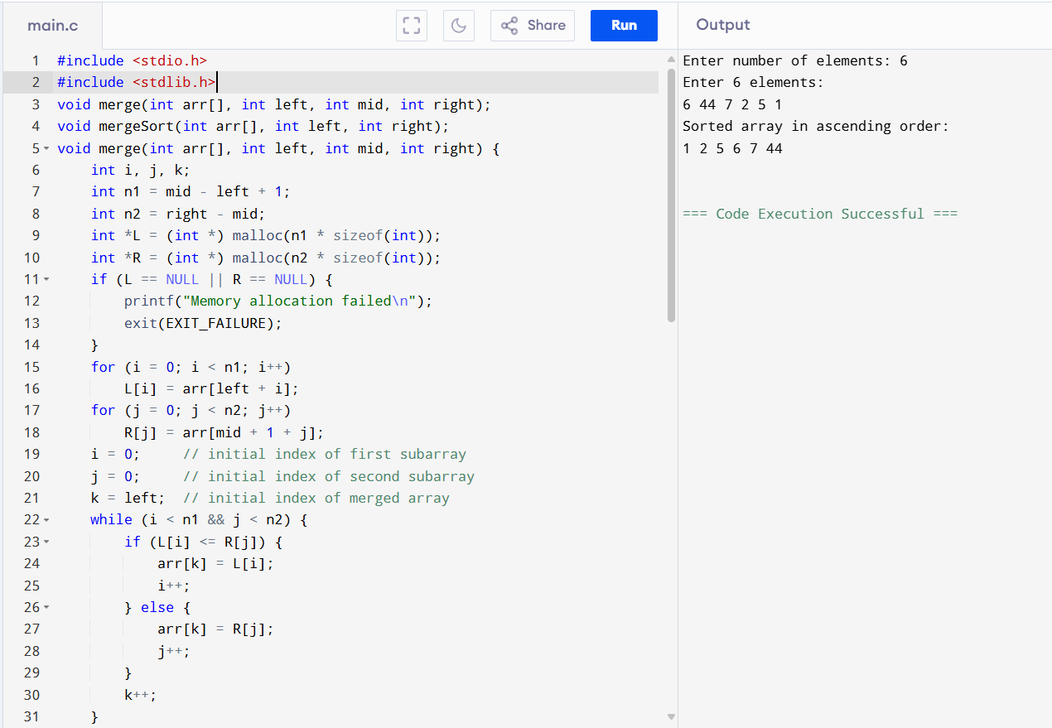

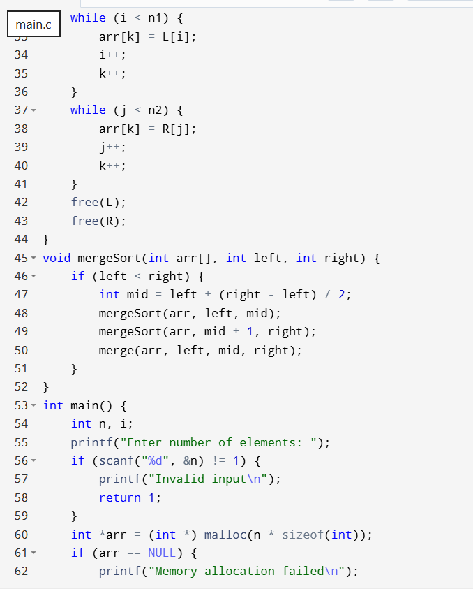

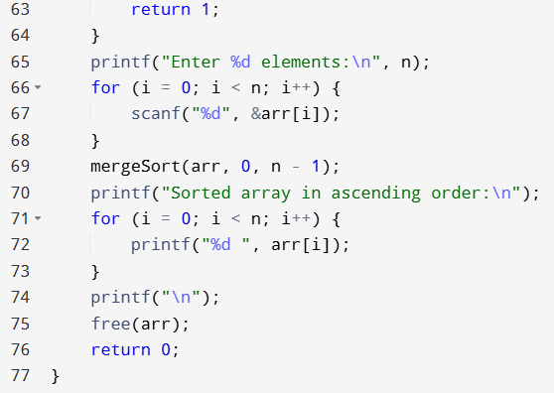

**Result:** The program has executed successfully and output is verified.